Question:01

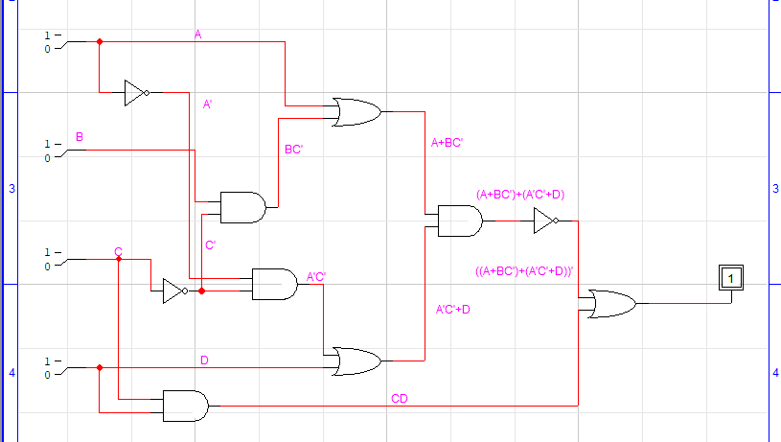

Truth Table:

|  |  |  |  |  |  |  |  |  |  |  |  |  |  |
| --- | --- | --- | --- | --- | --- | --- | --- | --- | --- | --- | --- | --- | --- |
| A | B | C | D | C’ | BC’ | A+BC’ | A’ | A’C’ | D+A’C’ | (A+BC’)(D+A’C’) | (A+BC’)(D+A’C’)’ | CD | (A+BC’)(D+A’C’)’+CD |
| 0 | 0 | 0 | 0 | 1 | 0 | 0 | 1 | 1 | 1 | 0 | 1 | 0 | 1 |
| 0 | 0 | 0 | 1 | 1 | 0 | 0 | 1 | 1 | 1 | 0 | 1 | 0 | 1 |
| 0 | 0 | 1 | 0 | 0 | 0 | 0 | 1 | 0 | 0 | 0 | 1 | 0 | 1 |
| 0 | 0 | 1 | 1 | 0 | 0 | 0 | 1 | 0 | 1 | 0 | 1 | 1 | 1 |
| 0 | 1 | 0 | 0 | 1 | 1 | 1 | 1 | 1 | 1 | 1 | 0 | 0 | 0 |
| 0 | 1 | 0 | 1 | 1 | 1 | 1 | 1 | 1 | 1 | 1 | 0 | 0 | 0 |
| 0 | 1 | 1 | 0 | 0 | 0 | 0 | 1 | 0 | 0 | 0 | 1 | 0 | 1 |
| 0 | 1 | 1 | 1 | 0 | 0 | 0 | 1 | 0 | 1 | 0 | 1 | 1 | 1 |
| 1 | 0 | 0 | 0 | 1 | 0 | 1 | 0 | 0 | 0 | 0 | 1 | 0 | 1 |
| 1 | 0 | 0 | 1 | 1 | 0 | 1 | 0 | 0 | 1 | 1 | 0 | 0 | 0 |
| 1 | 0 | 1 | 0 | 0 | 0 | 1 | 0 | 0 | 0 | 0 | 1 | 0 | 1 |
| 1 | 0 | 1 | 1 | 0 | 0 | 1 | 0 | 0 | 1 | 1 | 0 | 1 | 1 |
| 1 | 1 | 0 | 0 | 1 | 1 | 1 | 0 | 0 | 0 | 0 | 1 | 0 | 1 |
| 1 | 1 | 0 | 1 | 1 | 1 | 1 | 0 | 0 | 1 | 1 | 0 | 0 | 0 |
| 1 | 1 | 1 | 0 | 0 | 0 | 1 | 0 | 0 | 0 | 0 | 1 | 0 | 1 |
| 1 | 1 | 1 | 1 | 0 | 0 | 1 | 0 | 0 | 1 | 1 | 0 | 1 | 1 |

Question:02

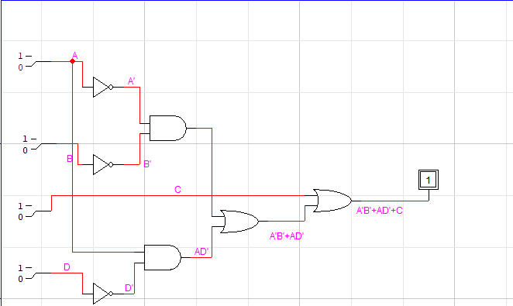

Truth Table:

|  |  |  |  |  |  |  |  |  |  |  |
| --- | --- | --- | --- | --- | --- | --- | --- | --- | --- | --- |
| A | B | C | D | A’ | B’ | D’ | A’B’ | AD’ | A’B’+AD’ | A’B’+AD’+C |
| 0 | 0 | 0 | 0 | 1 | 1 | 1 | 1 | 0 | 1 | 1 |
| 0 | 0 | 0 | 1 | 1 | 1 | 0 | 1 | 0 | 1 | 1 |
| 0 | 0 | 1 | 0 | 1 | 1 | 1 | 1 | 0 | 1 | 1 |
| 0 | 0 | 1 | 1 | 1 | 1 | 0 | 1 | 0 | 1 | 1 |
| 0 | 1 | 0 | 0 | 1 | 0 | 1 | 0 | 0 | 0 | 0 |
| 0 | 1 | 0 | 1 | 1 | 0 | 0 | 0 | 0 | 0 | 0 |
| 0 | 1 | 1 | 0 | 1 | 0 | 1 | 0 | 0 | 0 | 1 |
| 0 | 1 | 1 | 1 | 1 | 0 | 0 | 0 | 0 | 0 | 1 |
| 1 | 0 | 0 | 0 | 0 | 1 | 1 | 0 | 1 | 1 | 1 |
| 1 | 0 | 0 | 1 | 0 | 1 | 0 | 0 | 0 | 0 | 0 |
| 1 | 0 | 1 | 0 | 0 | 1 | 1 | 0 | 1 | 1 | 1 |
| 1 | 0 | 1 | 1 | 0 | 1 | 0 | 0 | 0 | 0 | 1 |
| 1 | 1 | 0 | 0 | 0 | 0 | 1 | 0 | 1 | 1 | 1 |
| 1 | 1 | 0 | 1 | 0 | 0 | 0 | 0 | 0 | 0 | 0 |
| 1 | 1 | 1 | 0 | 0 | 0 | 1 | 0 | 1 | 1 | 1 |
| 1 | 1 | 1 | 1 | 0 | 0 | 0 | 0 | 0 | 0 | 1 |

